TAGGING AND LABEL PROCEDURE FOR GUEST ARTISTS
Each artist is responsible for completing the artist inventory sheet, pricing, tagging and labeling of their artwork before bringing to the gallery on “put and take” day. If an item sells, the artist may replace the space with an item of similar size. Otherwise, items may not be added unless approved by the hanging committee.
Individual Inventory: Each artist is assigned a four digit ID number. (This number will be assigned to you upon joining the show). This number is part of your art item number. Each artist will complete an inventory list (Fig.1) (inventory lists and tags will be provided for you at the time of entry).
The item number column must be in numerical order.
LINE | Loc. | Item Number | Description | Medium | Bin? | Price | Sold Date | Sold By | Notes/Comments
# | UGLD | ####-#### | Bug Eyes | Photograph | x | $ | MM/DD/YY | #
1
Fig. 1
The inventory number consists of two four-digit numbers separated by a dash: The first four digits are for the artist number.(your assigned ID number). The last four digits are for the art inventory number specified by the artist. This number needs to be unique for each item.
The other fields are self-explanatory.
Labeling and Tagging:
ALL items must have a tag. Each artist is responsible for completing tags (Fig. 2). The information must be typed or printed in black ink in capital letters.
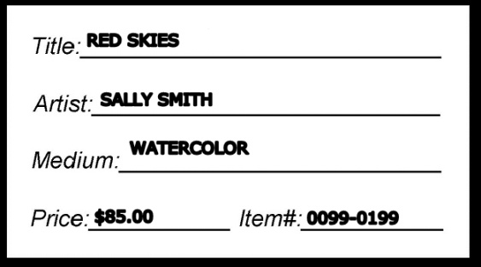 Fig. 2.

Please make sure your items have an identifying label affixed to the item to help keep track of inventory. You may use the same tag in Figure 2 or you may use your own.
The tag and/or label must be attached to the artwork in a spot that is easily visible to the customer. For example, labels can go on the bottom of ceramics and glassware and on the back of bin stock; tags can be attached by string to weaving and knitting. For wall art only - a label must be placed on the side or back of the item and a tag must be placed between the frame and glass, If a tag can’t be placed there, place it on the back (using tape or Sticky-Tac).
Tags will be placed on the wall or next to the items by the hanging committee. The tag and label item numbers must be listed on the inventory list.

